The Scientific Revolution & The Enlightenment

*REVISED* AP Euro Homework Assignments {Section 32-40}

_________________________________________________________________________________________

DATE: 1/23/14

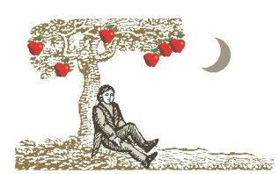TOPIC: "I think, therefore I am" and “The Road to Newton”

1. Lecture on Bacon and Descartes.
2. Lecture on the Road to Newton
3. Odds and Ends

HOMEWORK: DUE TUESDAY

1. P/C pp. 280-287: Section 34

(New Knowledge of Human Beings and Society)

1. P/C pp. 288-293: Section 35

(Political Theory: The School of Natural Law)

_________________________________________________________________________________________

DATE: 1/24/14 – ½ Day Schedule – No 4th Block

TOPIC: Good Luck on Any of Your finals HOMEWORK: Look ahead at next week’s homework

_________________________________________________________________________________________

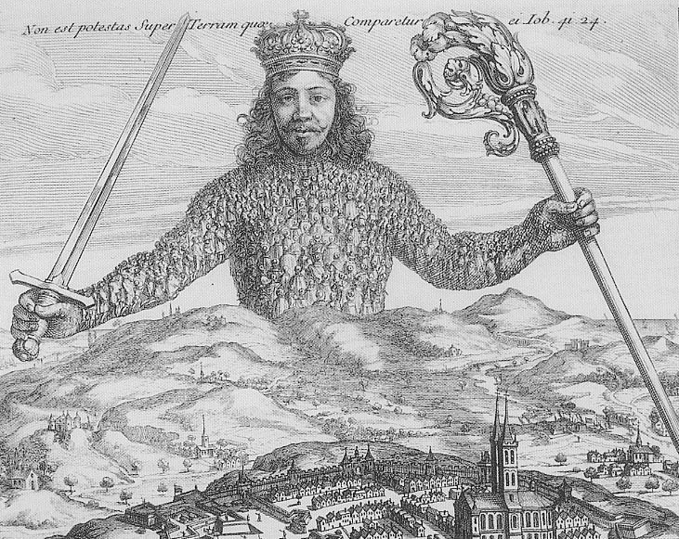DATE: 1/28/14

TOPIC: "New Knowledge?"

1. Lecture on Skepticism.
2. Search for Meaning WS
3. Lecture on Hobbes & Locke
4. Apply reading to discussion

HOMEWORK:

1. Study for quiz tomorrow: Bacon, Descartes, Newton, and New Knowledge.
2. P/C pp. 295-301: Section 36

(The Philosophes – and Others)

_______________________________________________________________________________________

DATE: 1/29/14

TOPIC: “Philosophes”

1. Chapter 7 Quiz
2. Lecture on the philosophes and physiocrats.
3. Old vs. New Order Worksheet

HOMEWORK: P/C pp. 301-317: Section 37

1. Finish Old vs. New Order Worksheet
2. (Enlightened Despotism: France, Austria, Prussia)
3. P/C pp. 317-323: Section 38

(Enlightened Despotism: Russia)

______________________________________________________________________________________

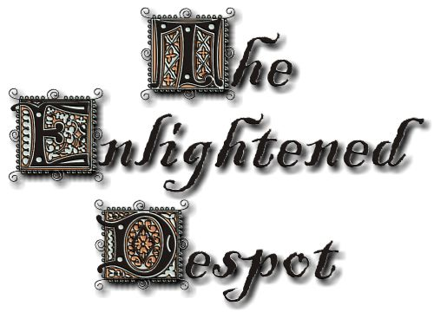DATE: 1/30/14

TOPIC: “Enlightened Despotism: France, Austria, Prussia, Russia”

1. Small Group Discussion and Debriefing
2. Lecture on Enlightened Despotism.
3. If time, create your own political cartoon

HOMEWORK:

1. P/C pp. 323-331: Section 39

(New Stirrings: The British Reform Movement)

1. P/C pp. 331-342: Section 40

(The American Revolution)

1. Possible Assignment – Political Cartoon due Monday

______________________________________________________________________________________

DATE: 1/31/14

TOPIC: “English Reform & American Revolution”

1. Comparison of Enlightened Despots.
2. Lecture on the British Reform movement.
3. Debrief and Discussion on The American Revolution

HOMEWORK: Take Home Enlightenment Quiz – due Monday